Sprint 3 - Agility Design Document

November 26, 2019

Anthony Cross, Khadar Estime, Robert Hart, and Isaiah Bishop

**Table of Contents**

**1.** **EXECUTIVE SUMMARY 3**

1.1 Project Overview 3

1.2 Purpose and Scope of this Specification 3

**2.** **PRODUCT/SERVICE DESCRIPTION 3**

2.1 Product Context 3

2.2 User Characteristics 3

2.3 Assumptions 3

2.4 Constraints 3

2.5 Dependencies 4

**3.** **REQUIREMENTS 4**

3.1 Functional Requirements 5

3.2 Security 5

*3.2.1* *Protection 5*

*3.2.2* *Authorization and Authentication 6*

3.3 Portability 6

**4.** **REQUIREMENTS CONFIRMATION/STAKEHOLDER SIGN-OFF 6**

**5.** **SYSTEM DESIGN 6**

5.1 Algorithm 6

5.2 System Flow 6

5.3 Software 6

5.4 Hardware 6

5.5 Test Plan 7

5.6 Task List/Gantt Chart 7

5.7 Staffing Plan 7

# Executive Summary

## Project Overview

The overall idea of this project is to design a code with our team for our robot to successfully complete the speed agility within our classroom of Howard Hall 208.

## Purpose and Scope of this Specification

The purpose of this project is to complete a flowchart and code for our sphero robot to complete the agility course around our HH208 classroom.

**In scope**

This document addresses requirements related to sprint 3 of our Robotics Project:

* modification of our flowchart and code are needed to meet the requirements for our agility course

# Product/Service Description

The general factors that could affect the product or its requirements are such as:

Group member availability

Algorithm completion

Test Run completion

## Product Context

This agility project is within itself its own code and project, however it also relates with two other parts of a larger project. Which are Sprint-1: Endurance and Sprinit-2: Speed.

## User Characteristics

General User Characteristics:

* Classmates and Professor of Howard Hall 208
* Complete the course and code correctly with robot
* Need to be able to understand sphero app and robot.

## Assumptions

There are many factors and assumptions that could go into the creation of this project, such as:

* Group member availability
* Getting the code correct
* Robot not working correctly

## Constraints

Items that will constrain the design options, including:

* floor texture
* correct code
* room space
* limits on robot use and sign outs
* Sphero app language compared to python language

## Dependencies

Examples:

* Our project needs to be worked on weekly in order to complete the Agility course.
* Our flowchart and code needs to be complete in order to complete the Agility course successfully

# Requirements.

* Priority 1 – Our robot must successfully run the agility obstacle course.
* Priority 2 – The robot must encounter 3 objects which it must avoid.
* Priority 3 – Our robot will move to stage 2 of the course and go over the ramp.
* Priority 4 – Then our robot must go to stage 3 of the course and go straight and knock down as many pins as possible.
* Priority 5 – Points will be added for each obstacle the robot completes, for each obstacle avoided, for each pin the robot topples and for each square the robot stops in during its run.

## Functional Requirements

|  |  |  |  |  |  |
| --- | --- | --- | --- | --- | --- |
| **Req#** | **Requirement** | **Comments** | **Priority** | **Date Rvwd** | **SME Reviewed / Approved** |
| Agility_01 | Run the first part of agility course | Code needs to be correct | 1 | 11/26 | Coder Approved |
| Agility_02 | Get around 3 objects of part 1 of sprint 3 | Code needs to be successfully | 2 | 11/26 | Tester 1  Approved |
| Agility_03 | Jump over ramp perfectly | Proper coding | 3 | 11/26 | All members  Approved |
| Agility_04 | Get to stage 3 of sprint 3 and successfully | Make sure this is in code and flowchart | 4 | 11/26 | All members  Approved |
| Agility_05 | Points will be added for each obstacle the robot completes, for each obstacle avoided, for each pin the robot topples and for each square the robot stops in during its run. | Need to practice course and correct code if wrong. | 5 | 11/26 | All members Approved |

## Security

We are using Github to secure our codes and project, while only the collaborators have access to the project.

# Requirements Confirmation/Stakeholder sign-off

Include documentation of the approval or confirmation of the requirements here:

|  |  |  |
| --- | --- | --- |
| **Meeting Date** | **Attendees (name and role)** | **Comments** |
| 11/26/2019 | Anthony Cross, Team Coder  Khadar Estime, Team Tester-01  Isaiah Bishop, Team Tester-02  Robert Hart, Team Task Manager and Tester-03 | confirmed by all team members:  Coder, Tester-01, Tester-02, Task Manager/Tester-03 |

# System Design

Code:

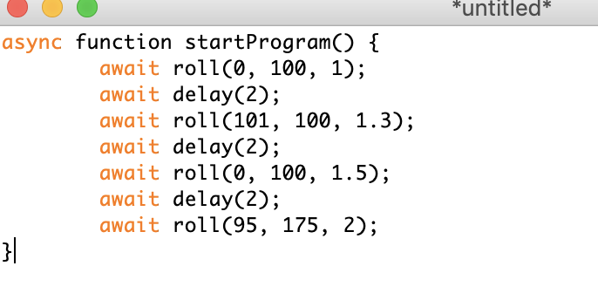

## Algorithm

Agility Algorithm

* Our goal for the agility course is to successfully run the obstacle course. The course starts out in the first square which we must avoid 3 objects. For each object our robot avoids we gain a point. Then the robot must jump over the ramp and land in or around stage 3. After we realign our robot we must then proceed forward, with great speed to knock down as many pins as possible.

## System Flow

Sprint-3 Flowchart:

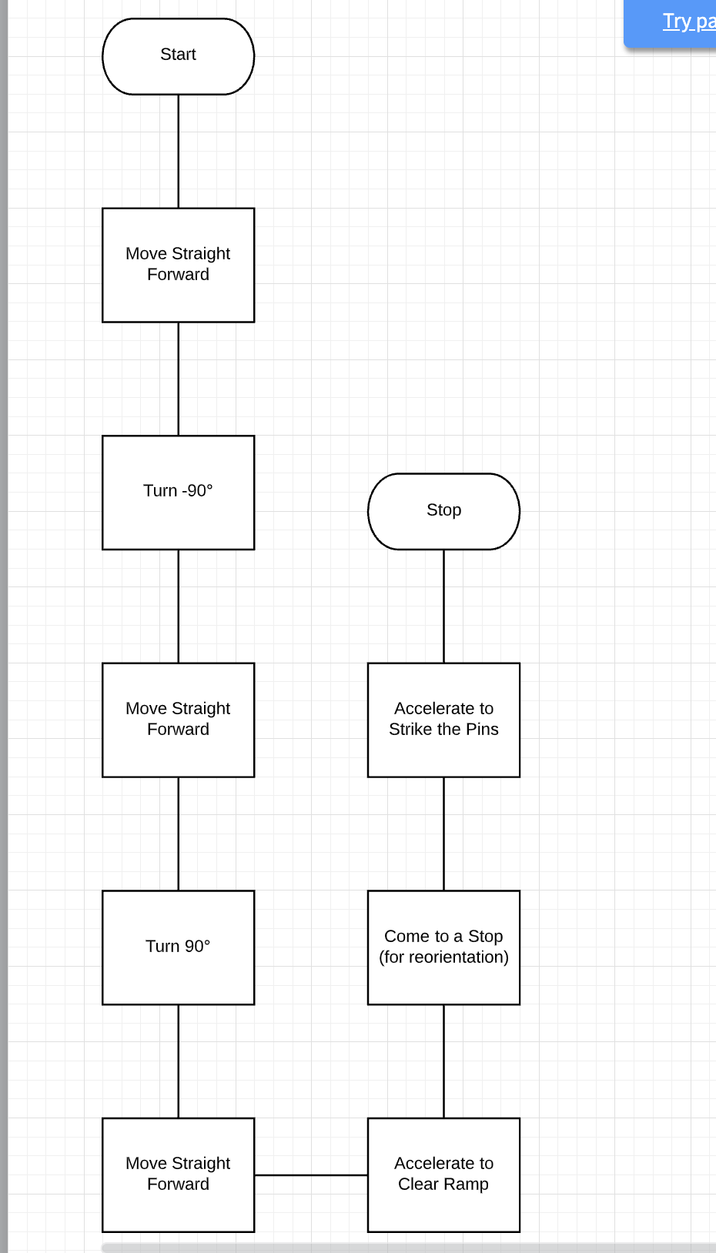

## Software

The sphero app and robot will be used to complete the endurance course.

## Hardware

The sphero app and robot will be used to complete the endurance course

## Test Plan

Include a test plan showing all unit tests performed for this application, Include test rational, test date, staff member, pass/fail status

|  |  |  |  |  |  |
| --- | --- | --- | --- | --- | --- |
| **Reason for Test Case** | **Test Date** | **Expected Output** | **Observed Output** | **Staff Name** | **Pass/Fail** |
| Avoid the first 3 objects | 11/26 | Correct Code and successful run. | Need to fix code | RH/IB | Fail |
| Jump the binder | 11/26 | Correct Code and successful run. | Get code correct | RH/IB | Pass |
| Start and finish in the square | 11/26 | Correct Code and successful run. | Make code successful | RH/IB | Pass |
| Test code and robot in HH208 | 11/26 | Correct assumptions and codes | Get group together to test code | RH/IB | Pass |

## Task List/Gantt Chart

Sprint 3-Gantt Chart:

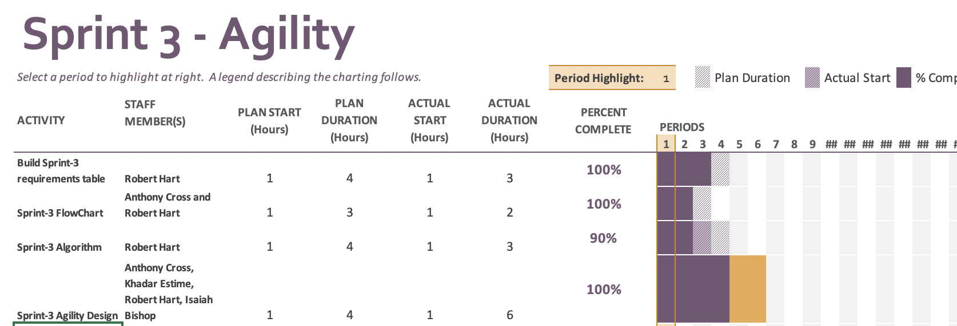

## Staffing Plan

Insert a chart/table that depicts the roles and responsibilities of each team member that worked on this project

|  |  |
| --- | --- |
| Name | Role |
| Robert Hart | Task Manager and Tester |
| Anthony Cross | Coder #2 |
| Khadar Estime | Tester |
| Isaiah Bishop | Coder #1 |